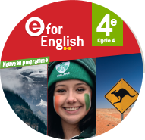 | Anglais  Words |  | Project 1
Premises |  | States and feelings
Persolan belongings |  | Personality
Intensity

Autres …

